OmegaT Installation guide for translators/reconcilers
Please read this guide till the end before proceeding with the installation.
OmegaT is the open source computer-assisted translation tool (CAT tool) which will be used to translate, reconcile, adapt, review and verify materials. The software has been customized to enable you to perform your task. Do not use any other version of OmegaT - it will not be able to read the files you will receive.
Note that there are two steps in the installation process:
- Install OmegaT (software itself)
- Install the customization features (that make this version compatible with the PISA materials).
Choose your path:
- If OmegaT is not installed in your computer, start at step 1.
- if you have OmegaT already installed but it's a version different from 4.2.0, please uninstall it and then proceed to step 1.
- If you have OmegaT already installed, and it's version 4.2.0, go directly to step 2.

Step 1 - Install OmegaT
Please download the installer that corresponds to the processor your computer has (32-bit or 64-bit). The links below point to version 4.2.0 of OmegaT. Do not install any other version.
Please do not download OmegaT from another link and please do not update OmegaT to a newer version unless you are instructed to do so.
During the installation:
- Choose English as the language of the installation and of the interface once installed
- In the License Agreement screen, please select “I accept the agreement” and click “Next”
- Do not change the default installation paths that the installer suggests
- You can choose to create a desktop shortcut
- In all other dialogs, just press “Next” to use the default options until you reach “Ready to Install” screen. Then click on “Install”.
If you're not allowed to install OmegaT in the default path C:\Program Files\OmegaT, you can try installing in another folder where you do have writing permissions:
e.g. C:\Apps\OmegaT, C:\Users\you\Desktop\OmegaT, etc.

Step 2 - Customize the OmegaT installation
After installing OmegaT, you will need to customize it. We provide a customization script that will add some configuration files to your OmegaT installation that you need to work with OmegaT project packages that you will download from the portal.
Please do not update OmegaT to a newer version even if OmegaT prompts you to.
- Download the updateConfigBundle.groovy script from . To do that, right click on the link and select “Save Link As” (or “Save Target As”, depending on your browser) (howto).
Download script
- In OmegaT, go to Tools > Scripting > File > Open script, and select the updateConfigBundle.groovy script from wherever you have saved it.
Open script
- Press the Run button at the bottom left of the Scripting dialog. Please read the final dialog.
Run script
- It could be that the script doesn't have permissions to touch certain files in your C:\Program Files\OmegaT\plugins folder. If necessary, delete the jar files manually.
Delete old plugins
- You could now delete the updateConfigBundle.groovy that you downloaded in step 1, you won't need it anymore.
This script will install all the necessary config files, scripts and plugins in OmegaT's User Configuration Folder.

Everything ok?
To check whether your installation and customization went fine, you can go to Tools and check whether you can see the script shortcuts under the Scripting header.
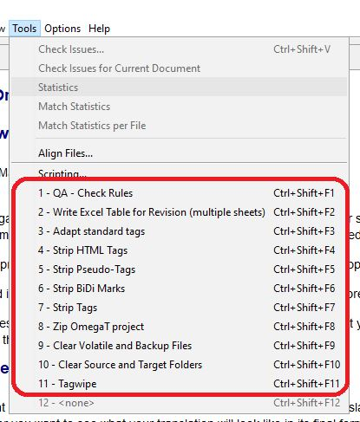

Auxiliary tools
If you need to insert non-breaking spaces in your translation, you will find the AutoHotKey script very useful.
- Download and install
- Open the Startup folder: Press Win+R on your keyboard and type shell:startup. The Startup folder opens. Copy the path to the startup folder (e.g. C:\Users\<your-username>\AppData\Roaming\Microsoft\Windows\Start Menu\Programs\Startup).
- Right click on the , choose “Save link as” and paste the path to the Startup folder.
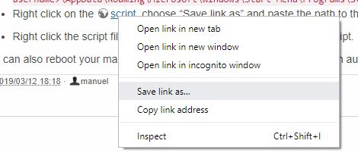
- Right click the script file (insert_unicode_char.ahk) and choose Run script.
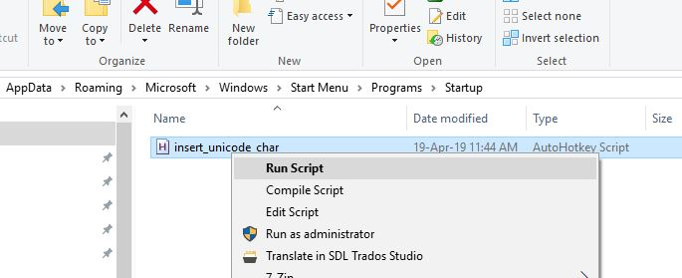
This script will be run automatically the next time your machine starts.

